**VARIOUS ENVIRONMENT USED FOR PYTHON PROGRAMMING**

For writing python code, there are various Python IDEs and code editors are available. A code editor is a tool used to write and edit code. An IDE (Integrated Development Environment) understand the code much better than a text editor.

Following our some of the code editors and IDEs used for Python programming.

1. **IDLE**

When we install python, IDLE is also installed by default. Its major features include the Python shell window (interactive interpreter), auto-completion, syntax highlighting, smart indentation, and basic integrated debugger.

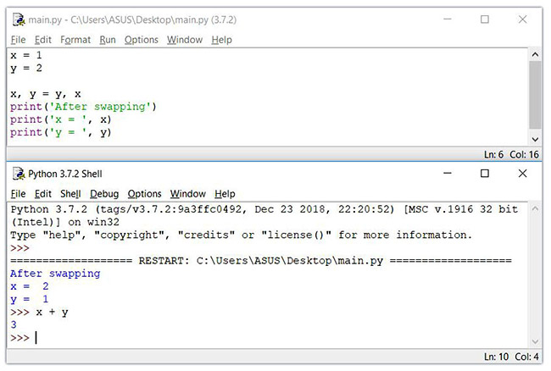

1. **Sublime Text 3**

Sublime Text is a popular code editor that supports many languages including Python. It’s fast, highly customizable and has a huge community. It has basic built-in support for Python when you install it. However, packages can be installed such as debugging, auto-completion, code linting, etc. There are also various packages for scientific development, Django, Flask and so on. We can customize Sublime text to create a full-fledged Python development environment as per need.

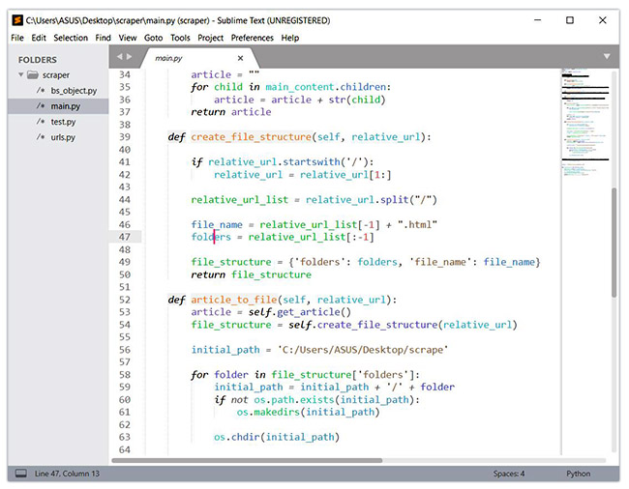

1. **PyCharm**

PyCharm is an IDE for professional developers. It is created by JetBrains, a company known for creating great software development tools. PyCharm provides all major features that a good IDE should provide: code completion, code inspections, error-highlighting and fixes, debugging, version control system and code refactoring.

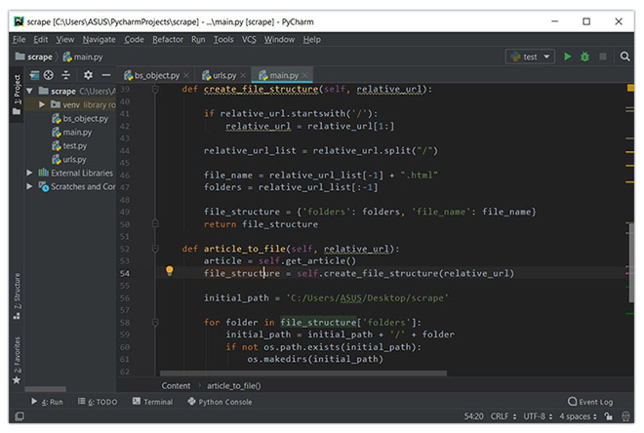

1. **Visual Studio Code**

Visual Studio Code (VS Code) is a free and open-source IDE created by Microsoft that can be used for Python development. We can add extensions to create a Python development environment as per your need in VS code. It provides features such as intelligent code completion, linting for potential errors, debugging, unit testing and so on. VS Code is lightweight and packed with powerful features. This is the reason why it becoming popular among Python developers.

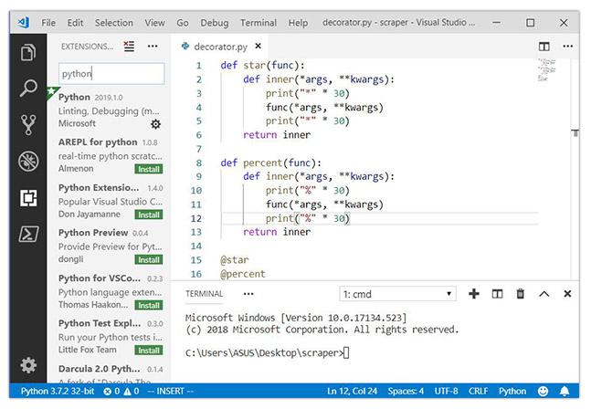

1. **Vim**

Vim is a text editor pre-installed in Linux and macOS systems. We need to download it for windows. It has its own keyboard shortcuts and commands. It’s also extendible. We can add plugins for syntax highlighting, code completion, debugging, refactoring, etc. to Vim and use it as Python IDE.

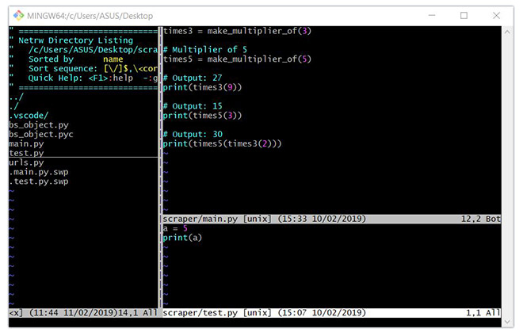

1. **Spyder**

Spyder is an open-source IDE usually used for scientific development. The easiest way to get up and running up with Spyder is by installing Anaconda distribution. Spyder has some great features such as autocompletion, debugging and iPython shell. However, it lacks in features compared to PyCharm.

